**ELECTIVE 3: FULLSTACK WEB DEVELOPMENT**

**PRELIMINARY EXAMINATION**

**2nd Semester, Academic Year 2020-2021**

Please follow the directions for each section. Note that in each section you will have some amount of choice in the questions you’ll be answering. The exam is based on a 100-point scale. Partial credit will be given for answers that are done partially well.

**Programming** (50 points ).

1. Requirements:
   * 1. Copy and download source of this website blog layout shown here : <https://getbootstrap.com/docs/5.0/examples/blog/#>
     2. Here is the source of codes in HTML: <https://getbootstrap.com/docs/5.0/examples/>
2. Create the below
   1. Follow layout below, create project file in Github with the following naming convention, E3ME_LASTNAME_FIRSTNAME (upper case)
   2. Fonts can be altered and changed
   3. DATA IS NOT NEEDED - for now. Let’s make this static.

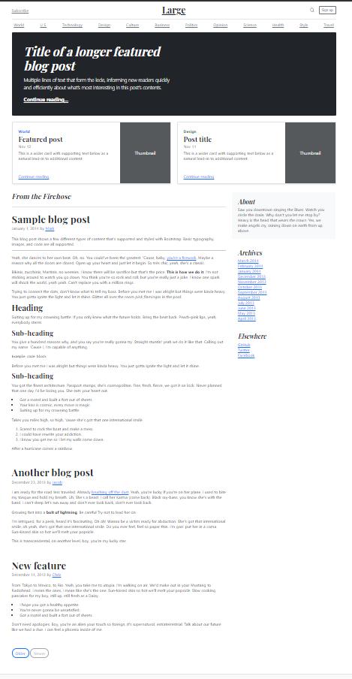

**Essay** (25 points):

1. Create a sample code snippet that demonstrates passing a callback function from a parent component down to its child(ren) component.
2. import React from 'react';
3. function Parent(){
4. const data = 'Data from parent';
5. return(
6. <div>
7. <Child dataParentToChild = {data}/>
8. </div>
9. )
10. }
11. function Child ({dataParentToChild}){
12. return(
13. <div>
14. {dataParentToChild}
15. </div>
16. )
17. }
18. export default Parent;
19. Explain props-drilling.

Props Drilling (Threading) is a concept that refers to the process you pass the data from the parent component to the exact child Component **but** in between, other components owning the props just to pass it down the chain. It refers to the process you have to go through to get data to parts of the React Component tree.

Example:

1 function Toggle() {

2 const [on, setOn] = React.useState(false)

3 const toggle = () => setOn(o => !o)

4 return <Switch *on*={on} *onToggle*={toggle} />

5 }

6

7 function Switch({on, onToggle}) {

8 return (

9 <div>

10 <SwitchMessage *on*={on} />

11 <SwitchButton *onToggle*={onToggle} />

12 </div>

13 )

14 }

15

16 function SwitchMessage({on}) {

17 return <div>The button is {on ? 'on' : 'off'}</div>

18}

19

20 function SwitchButton({onToggle}) {

21 return <button *onClick*={onToggle}>Toggle</button>

22 }

This is prop drilling. To get the on state and toggle handler to the right places, we have to drill (or thread) props through the Switch component. The Switch component itself doesn't actually need those values to function, but we have to accept and forward those props because its children need them.

|  |  |  |
| --- | --- | --- |
| Prepared By:  NINO FRANCISCO ALAMO  Professor /Instructor | Reviewed By:  REGIE ELLANA  CCS Dean | Approved By:  DR. LEAH DIGO  VP for Academic Affairs |

|  |
| --- |
| **LOA-OAA-TOS-028** |
| **10-02-2020 | REV. 00** |

|  |  |
| --- | --- |
| **CODE** | **ELEC323** |
| **TITLE** | **ELECTIVE 3: FULLSTACK DEVELOPMENT** |
| **EXAM** | **PRELIMINARY EXAMINATION** |
| **TERM/AY** | **2ND SEMESTER, ACADEMIC YEAR 2020-2021** |

|  |  |  |  |  |  |  |  |  |
| --- | --- | --- | --- | --- | --- | --- | --- | --- |
| **Topic #** | **Objectives** | **Remember** | **Understand** | **Apply** | **Analyze** | **Evaluate** | **Create** | **Total # of Items/points** |
| 1 | * To apply the concepts of MVC   + - * + Creating Views         + Persisting to Database | 2 | 2 | 2 | 1 | 1 | 2 | **10** |
| **Total # of items/Points** | | 2 | 2 | 2 | 1 | 1 | **2** | **10** |

|  |  |  |
| --- | --- | --- |
| Prepared By:  NINO FRANCISCO ALAMO  Professor /Instructor | Reviewed By:  REGIE ELLANA  CCS Dean | Approved By:  DR. LEAH DIGO  VP for Academic Affairs |